# | Params | WR% | W/L | PnL | Expect | PF | DD
1 | multiplier: 1  body ratio: 1  breakout confirm bars: 3 | 64.7% | 22/12 | +10R | +0.294 | 1.83 | -2R | Aplicar
2 | multiplier: 2  body ratio: 0.90  breakout confirm bars: 1 | 60% | 30/20 | +10R | +0.2 | 1.5 | -4R | Aplicar
3 | multiplier: 2  body ratio: 1  breakout confirm bars: 4 | 60% | 30/20 | +10R | +0.2 | 1.5 | -5R | Aplicar
4 | multiplier: 2  body ratio: 0.90  breakout confirm bars: 2 | 58% | 29/21 | +8R | +0.16 | 1.38 | -6R | Aplicar
5 | multiplier: 2.75  body ratio: 0.90  breakout confirm bars: 1 | 58% | 29/21 | +8R | +0.16 | 1.38 | -3R | Aplicar
6 | multiplier: 3  body ratio: 0.90  breakout confirm bars: 1 | 58% | 29/21 | +8R | +0.16 | 1.38 | -3R | Aplicar
7 | multiplier: 2  body ratio: 0.60  breakout confirm bars: 5 | 73.3% | 11/4 | +7R | +0.467 | 2.75 | -1R | Aplicar
8 | multiplier: 2.25  body ratio: 0.60  breakout confirm bars: 5 | 73.3% | 11/4 | +7R | +0.467 | 2.75 | -1R | Aplicar
9 | multiplier: 0.75  body ratio: 1  breakout confirm bars: 6 | 80% | 8/2 | +6R | +0.6 | 4 | -1R | Aplicar
10 | multiplier: 1  body ratio: 0.90  breakout confirm bars: 3 | 62.5% | 15/9 | +6R | +0.25 | 1.67 | -2R | Aplicar
11 | multiplier: 2.25  body ratio: 0.70  breakout confirm bars: 5 | 56.8% | 25/19 | +6R | +0.136 | 1.32 | -6R | Aplicar
12 | multiplier: 2.25  body ratio: 0.90  breakout confirm bars: 1 | 56% | 28/22 | +6R | +0.12 | 1.27 | -4R | Aplicar
13 | multiplier: 2.50  body ratio: 0.60  breakout confirm bars: 5 | 68.8% | 11/5 | +6R | +0.375 | 2.2 | -1R | Aplicar
14 | multiplier: 2.50  body ratio: 0.90  breakout confirm bars: 1 | 56% | 28/22 | +6R | +0.12 | 1.27 | -4R | Aplicar
15 | multiplier: 2.75  body ratio: 0.60  breakout confirm bars: 2 | 66.7% | 12/6 | +6R | +0.333 | 2 | -1R | Aplicar

=================================
r/r =4
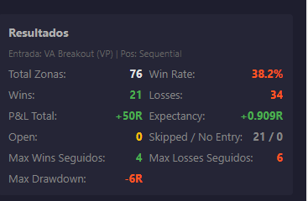

r/r=2

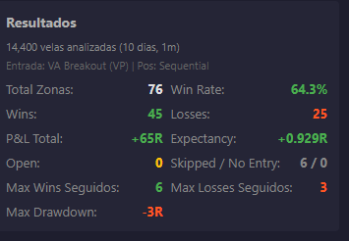

r/r =1

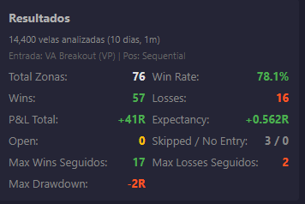

r/r=1,5

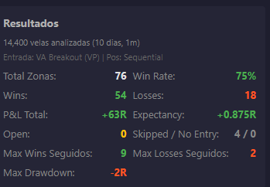

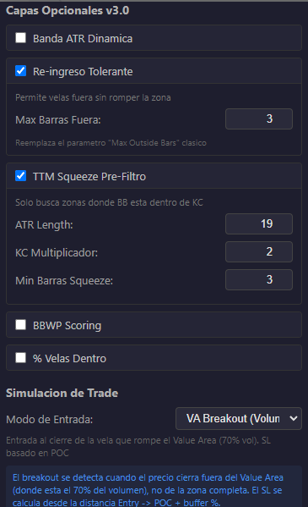
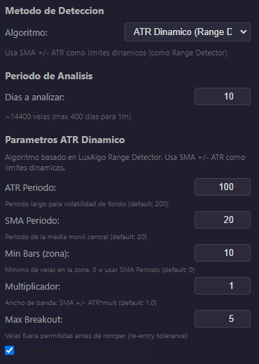
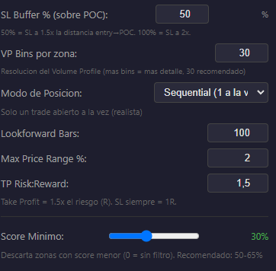

=======================================================================
Optimizando el r/r con el % del buffer del stoploss al POC en un periodo de 30 días.

# | Params | WR% | W/L | PnL | Expect | PF | DD
1 | tp rr ratio: 4  sl poc buffer pct: 20 | 75% | 3/1 | +11R | +2.75 | 12 | -1R | Aplicar
2 | tp rr ratio: 4  sl poc buffer pct: 30 | 75% | 3/1 | +11R | +2.75 | 12 | -1R | Aplicar
3 | tp rr ratio: 4  sl poc buffer pct: 40 | 75% | 3/1 | +11R | +2.75 | 12 | -1R | Aplicar
4 | tp rr ratio: 4  sl poc buffer pct: 50 | 75% | 3/1 | +11R | +2.75 | 12 | -1R | Aplicar
5 | tp rr ratio: 3.50  sl poc buffer pct: 20 | 75% | 3/1 | +9.5R | +2.375 | 10.5 | -1R | Aplicar
6 | tp rr ratio: 3.50  sl poc buffer pct: 30 | 75% | 3/1 | +9.5R | +2.375 | 10.5 | -1R | Aplicar
7 | tp rr ratio: 3.50  sl poc buffer pct: 40 | 75% | 3/1 | +9.5R | +2.375 | 10.5 | -1R | Aplicar
8 | tp rr ratio: 3.50  sl poc buffer pct: 50 | 75% | 3/1 | +9.5R | +2.375 | 10.5 | -1R | Aplicar
9 | tp rr ratio: 3.50  sl poc buffer pct: 60 | 75% | 3/1 | +9.5R | +2.375 | 10.5 | -1R | Aplicar
10 | tp rr ratio: 3.50  sl poc buffer pct: 70 | 75% | 3/1 | +9.5R | +2.375 | 10.5 | -1R | Aplicar
11 | tp rr ratio: 3  sl poc buffer pct: 20 | 75% | 3/1 | +8R | +2 | 9 | -1R | Aplicar
12 | tp rr ratio: 3  sl poc buffer pct: 30 | 75% | 3/1 | +8R | +2 | 9 | -1R | Aplicar
13 | tp rr ratio: 3  sl poc buffer pct: 40 | 75% | 3/1 | +8R | +2 | 9 | -1R | Aplicar
14 | tp rr ratio: 3  sl poc buffer pct: 50 | 75% | 3/1 | +8R | +2 | 9 | -1R | Aplicar
15 | tp rr ratio: 3  sl poc buffer pct: 60 | 75% | 3/1 | +8R | +2 | 9 | -1R | Aplicar

